Which of the following is meta directing group?
A.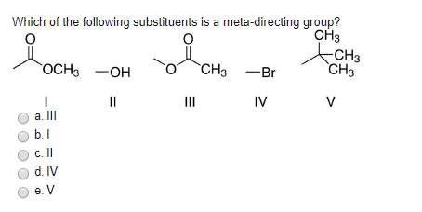
B. 
C. 
D.

ANSWER: B
The following compound is _____.In a reaction, phenol is added or mixed with nitric acid in presence of $H_{2}SO_{4}$. The final product is _____.
A. m-Nitrophenol
B. p-Nitrophenol
C. o-Nitrophenol
D. Both A and B
E. Both B and C
ANSWER: E
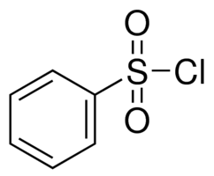

A. Electron withdrawing deactivating group
B. Electron donating activating groups.
C. Electron donating deactivating group
D. Electron withdrawing activating group
ANSWER: A
Choose the suitable reagent to carry out this reaction.
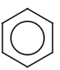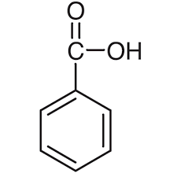
A. $CH_{3}Cl, KMnO_{4}/Acid$
B. $CH_{3}Cl, H_{2}SO_{4}$
C. $AlCl_{3}/CH_{3}Cl,KMnO_{4}$
D. ${CH_{3}Cl, H}_{2}O/H_{2}SO_{4}$
ANSWER: C
$$\underset{→}{ ? }$$
Select suitable numbering of the steps to undergo this reaction?
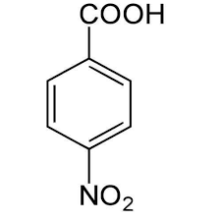
$$\underset{→}{ ? }$$
I. $KMnO_{4}/acid$
II. $HNO_{3}/H_{2}SO_{4}$
III. $CH_{3}Cl/FeCl_{3}$
A. I, III and II
B. I, II and III
C. III, II and I
D. II, III and I
ANSWER: C
Ortho and para directing groups are known as____.
A. Electron withdrawing groups
B. Electron donating groups.
C. Deactivating groups.
D.None of these
ANSWER: B
Meta directing groups are known as____.
A. Electron withdrawing groups
B. Electron donating groups.
C. Activating groups.
D. None of these
ANSWER: A
Which of the following group is deactivating group?
A. $-NO_{2}$
B. $-COOH$
C. $-Cl$
D. All of these
ANSWER: C
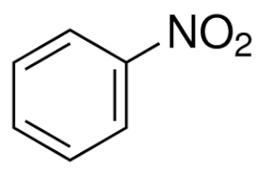
$$+HONO_{2}\begin{aligned}\underset{→}{ H_{2}SO_{4} } \\ dilute\end{aligned}$$
A. Ortho dinitrobenzene and water
B. Para dinitro benzene and water
C. Meta dinitro benzene and water
D. 2, 4, 6- trinitro benzene and water
E. None of these
ANSWER: C

Phenol reacts with concentrated nitric acid to form:
A. o-Nitrophenol
B. 2,4,6-trinitrophenol
C. Does not react with conc. Nitric acid
D. Both A and B
ANSWER: B
Which of the following alkyl halide will be used to prepare cumene from benzene?
A. Ethyl chloride
B. Propyl chloride
C. Hexyl chloride
D. None of these
ANSWER: B
Which of the following reagent will form maleic anhydride with benzene?
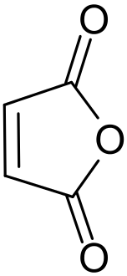
$$\underset{→}{ ? }$$
A. Oxygen in the presence of Vanadium pentoxide
B. Ozone
C. $KMnO_{4}$
D. All of these
ANSWER: A
Choose the suitable reagent to carry out this reaction.

A. Oxygen in the presence of Vanadium pentoxide
B. Ozone
C. $KMnO_{4}$
$$\underset{→}{ ? }O=CH-CH=O$$
D. All of these
ANSWER: B
Benzene can be converted to toluene by using
A. Friedel Craft Alkylation
B. Friedel Craft Acylation
C. Nitration
D. Oxidation
ANSWER: A
Choose the suitable reagent to carry out this reaction.
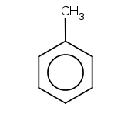
A. $KMnO_{4}/Acid$
B. $H_{2}SO_{4}$
C. $AlCl_{3}/CH_{3}COCl$
D. $H_{2}O/H_{2}SO_{4}$
ANSWER: A
$$\underset{→}{ ? }$$

